**NH CATHOLIC YOUTHFEST**

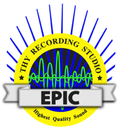

**Saturday, 5.6.17, 9am - 6:30pm**

**Saint Anselm College, Sullivan Arena, Manchester, NH**

**Get all the details for an EPIC Event at nhyouthfest.org**

**Our Epic Day:**

**Prayer, friends & fun, awesome lunch options**

**Great music, talks, vendors, small group sessions**

**Mass with Bishop Libasci, Reconciliation, Adoration**

**SIGN UP THROUGH OUR PARISH BY: ____________ to get the Early Discount**

**Registration fee: $35 thru ____________**

**$50 per person after _____________**

**Transportation:**

**Permission Form:**

**Chaperones Info:**

***Youthfest is a great opportunity to introduce new adults to youth ministry and build your team. Invite parents to share in the day***

**For more event details:**

[**www.nhyouthfest.org**](http://www.nhyouthfest.org)

[**NHCatholicYouthfest@gmail.com**](mailto:NHCatholicYouthfest@gmail.com)

**www.facebook.com/NHYouthfest**